Computer Problem 3

# Part 1

*MLE of scalar a*

Using the MLE the expression for ‘a’ is

$$a= {(x^{T}x)}^{-1}x^{T}y$$

Where x is the training image and y is the test image

Given the two sample images the MLE for a in this case is

$$a= 0.679618339126851$$

# Part 2

*NN classifier using MLE normalization*

Using the expression for ‘a’ above, we can estimate an uncorrupted normalized version of the test image and find the Euclidean distance between it and a corresponding training image. Then all we have to do is find the training image that yields the smallest distance and classify the test image. Note that for each distance calculation there is a different scalar ‘a’ used for normalization.

Below is the plot of the class conditional errors using this method.

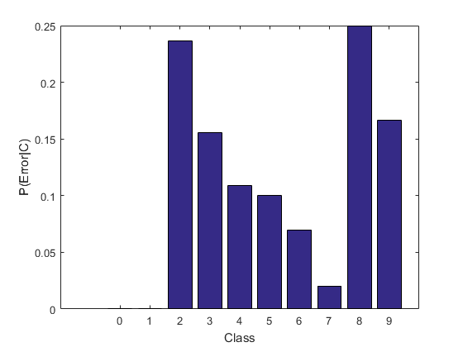

The total error rate was calculated to be

$$P(error) = 0.108$$

# Part 3

*Standard NN classifier*

Here are the resulting error rates when using a standard NN classifier.

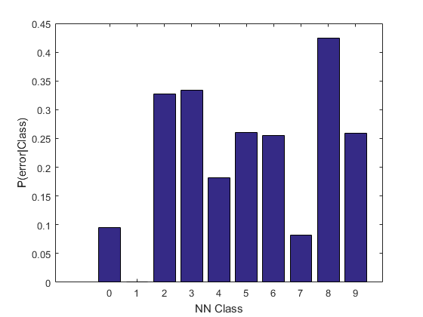

The total error rate for this method is

$$P\left(error\right)= 0.212$$

# Conclusion

As we can see, the total error rate and the individual error rates given class labels for the NN classifier using normalized test data is absolutely lower than the standard NN classifier. Below is a scaled version of the figures above for easier comparison visualization.

 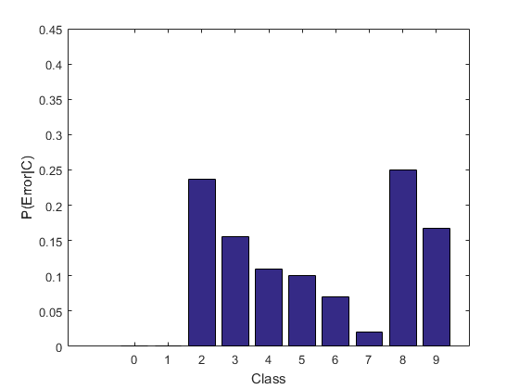

The figure on the left is the Standard NN classifier. The figure on the right is the NN classifier using MLE normalized test images.